Event Management Plan
Drone Racing Event
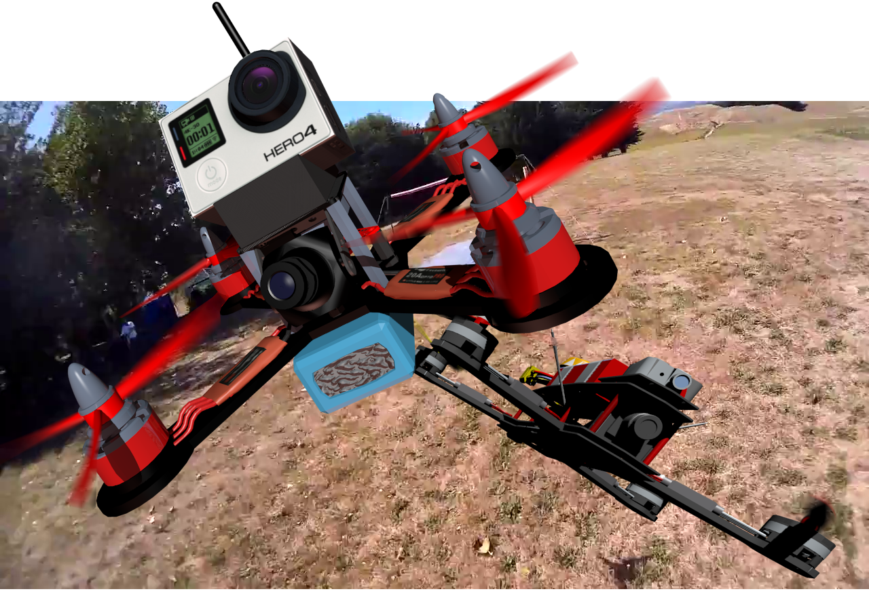

Event Overview
Remotely piloted aerial systems (RPAS) or more impolitely known as “drones” are the epitome of what “high tech” means. This event celebrates science, technology, engineering, mathematics, and manufacturing (STEMM), all of which are bundled into drone technology and the pilot's knowledge of how to build them, fly them, and keep them running. With the rapid rise of drone racing as an organised sport internationally and locally, it seems fitting to run a showcase event.
Drone racing tests both the piloting skill of the participants and the speed and agility of their drones as they race them through a course consisting of straights, bends, slalom section, and many obstacles including hoops and vertical turns.
The drone pilots use a video system called “FPV” (First person view) that enables them to see the view from the point of view of the drone as if they were sitting inside it. They control the drone with standard model aircraft radio control units.
The all-day event will be held in the [location], and this will happen on [dates and times], weather permitting. If the event is postponed due to poor weather, it will happen on [some other dates and times]. The day will feature talent from [Whatever organisation] and invited others.
It is a free event, and it is expected that spectators are likely to come and go as they please. There is a nominal fee for the participants. This will be handled by [Whatever organisation].
The organisers are committed to running a safe and enjoyable event that showcases the fast moving, exciting, and rapidly growing new sport of drone racing.

Detailed Timetable

Already arranged
The following actions have already been completed or are close to being completed at the time of writing this plan.

Airspace permission
The event has been registered and approved on the official Airshare website.
The flight registration details are:
- Flight ID: 32670
- Flight Name: Drone Racing Event
- Flight Time/Date: 08:00 21/05/17
- Pilot (day of flight): Rotorcross NZ and MFNZ, 021 149 0052
- Vehicle Type: UAV/RPAS/UAS, Rotary wing
- Control Zone: Wellington
https://www.airshare.co.nz/my-flights/app/#/detail/32731
This is considered a “Shielded Operation” and so does not need authorisation from Air Traffic Control or agreement from the Avalon Helipad Aerodrome Operator.
Shielded operations must be:
- Within 100m of, and below the top of, a natural or man-made object
- Outside the boundary of an aerodrome
- Physically separated from the aerodrome by a barrier that is capable of arresting the flight of the aircraft
The event will adhere to Civil Aviation Rule Part 101.

Health and Safety Plan
The Health and Safety plan has been written and approved.

Promotion
Promotion is ongoing and growing. To date the event is being promoted to the public through the following websites.

The event is being promoted to pilots through the following website.
[Whatever you are using]

Week Prior

Video Receivers
Borrow the Video Receivers and Video Equipment Prepared.

Track Weather Developments.
If severe weather predicted for weekend and the forecast appears to be consistently predicting this in the few days leading up to the weekend, a decision on whether to postpone should be made and the postponement plan put into action.

Two Days Out from Event - [Date]

Track Weather Developments.
If severe weather is predicted for weekend and the forecast still appears to consistently predict this, a decision on whether to postpone should be made and the postponement plan put into action.

Access to Hutt Rec
Obtain access to the event location and finalise all details for entry on the day.

Gather materials for obstacles, Hi-viz gear, and barriers
Pick up items from [storage location(s)]. This includes all materials for creating the course, and barriers for spectator control.

Day Before Event - [Date]

Track Weather Developments.
If severe weather predicted for the next day, a decision on whether to postpone should be made and the postponement plan put into action.

Additional Materials for Construction of Course
Gather materials for course from [any other storage location(s)]. This includes all electrical cabling for supply to the equipment.

Day of the Event - [Date]
7:30 – 8:30 | Delivery of Materials and Equipment by Third-Party Suppliers
8:00am | Access to the grounds and opening up grandstand (if required)  Plan course  Run power cables
8:30am | Video Supplier arrives and sets up the video system
9:00am | The pilots and organisers will set up the pilots area and course.  Lay out trees and plants  Set out course  Mark out 20m separation area  Set up charging stations  Finalise preparation of the spectator areas.
10:00am | Pilot’s briefing and assignment of frequencies
10:15am | Racing begins
12:00pm | Break for lunch – Practice rounds
12:30pm | Racing resumes
3:00pm | Racings Finished
3:30pm | Prizegiving (if there is one) and packdown begins  Materials and Equipment collected by Third-Party Suppliers.
3:45pm | Packdown  Dismantle separation area boundary  Pack away charging stations  Pack away video equipment ready for collection. (Video Supplier will do this)  Recover all course materials  Gather all power cables  Return all hired vegetation to pickup point.  Close grandstand once spectators gone.
5:00pm | Field clear.

Day after the Event - [Date]
The activities described below may happen immediately after the event. This will be confirmed with the various other organisations involved.
Third party suppliers arrange drop off and pick up of their equipment.
Return borrowed equipment to the [respective storage locations].

Postponement
Drone racing is weather dependent and so postponement due to poor weather is possible. The date to postpone to is [Another date for the second attempt].
The decision to postpone the event will be made by the organisers.
The decision to postpone (or cancel) will be made as early as possible and no later than the morning proceeding the event.

Notification of Postponement
- [Organiser's name] will contact [event host, and hosting location]
- [Organiser's name] will contact Third party Suppliers.
- [Organiser's name] will contact [various social media and public noticeboard services] to arrange notice of cancellation on the various social media options available as well as Event promotion websites.
- [Organiser's name] will contact the participants to advise of posponement and also post note on [organisation] websites as appropriate.

Lead up to the Postponed Event Date - [Date]
The activities in the lead up to the [Postponement Date] will be exactly the same as described for the lead up to the [Original Event Date] except cancellation may be required if the weather continues to be poor for the weekend of the [Postponement Date]. The decision to cancel the event will be made by the organisers.

Cancellation
In the event of the weather being too bad for the [Postponement Date] the event will need to be cancelled. The decision to cancel the event will be made by the organisers. The decision to cancel will follow the same timing and notification as for postponement.

Contact Details

Event Organisers

Backup Contact

Location

Suppliers

Event plan prepared by [ ]. Date [ ]

