3D Printing Introduction
Throughout this Workshop I will be referring to a number of websites. In order to save you having to note them all down this document seeks to provide you with a guide about where to find some of the things referred to and some hints and tips along the way that may help you get underway with the package(s) you choose to adopt.

Where to find 3D Digital Models to Print
There are two main repositories of 3D models that are print ready (in theory). Caution must be exercised when looking at these models because the models submitted are not moderated at all and some of them are not printable.

Thingiverse is the largest of them and the website is http://www.thingiverse.com. Using the “Explore” button in the top menu bar will allow you to search the flood of models present on this site. While the website is closely associated with Makerbot the models are all in the standard STL format that any 3D Printer can use.

Youmagine is very similar to Thingiverse but is more closely related to the Ultimaker 3D printer. It is a smaller repository. The website is; https://www.youmagine.com/. Again, all models are in an STL format.

Shapeways is not for downloading models but is a place were you can upload your models and even offer your designs for sale. Shapeways using powder printing technologies to realise the submitted digital models in metals, plastics, ceramics etc. Their website is http://www.shapeways.com.

Ponoko is partly based in Wellington and offer laser cutting services. They may be offering 3D printing services soon. Their website is https://www.ponoko.com/.

Other businesses are beginning to offer 3D Printing services for people who are designing but do not yet own a printer themselves. One such place is Ancoprint (http://www.ancoprint.co.nz/) who also offer a scanning service. At this stage I am unsure of the full list but I understand it is beginning to grow. http://www.3dhubs.com/ is a website that will allow users to connect with people offering their home or small workshop 3D printers as a local printing service. At this time there are a couple of people in the Wellington region who can print items through this network. Obviously the 3dhubs network means you can design something for someone who may be on the other side of the world and then get someone local to them to print it out and deliver it to them.

How to make your own 3D Digital Models
Photogrammetry is a method for capturing the shape of an existing model by taking a number of photographs from different angles and letting some software workout what shape could have produced that image. The models produced will need a little bit of cleanup but produce some very impressive results. If you like sculpting things by hand you may find this to your liking. A free service is 123D Catch and can be found on this website; http://www.123dapp.com/catch

Blender
Blender is a very powerful open source graphics package primarily designed for modeling to produce rendered still images and animations. It is also very well set up to produce accurately dimensioned models for 3D printing. The Blender development community has recognised this and the latest editions now include a suite of tools for checking the models produced to ensure they are print ready.

The website for obtaining a copy is http://www.blender.org. The software is free.

32 bit Linux and Windows versions are available on the CD.

Sketchup
Sketchup is a free modeling package that is intuitive to learn. The models that it can produce can be quite complex but sometimes the mesh quality is problematic when it comes to the Slicing process to make it ready for a 3D Printer. The website for Sketchup is http://www.sketchup.com/.

The Pro version has many different formats for exports, but the free version does not. To produce the STL format you will need a plugin which can be found here; http://www.guitar-list.com/software and the plugin itself is
http://www.guitar-list.com/sites/default/files/skp_to_dxf.rb. You will find instructions on how to install the plugin on the website.

Sketchup has a large repository of community produced models associated with it. This is found here; https://3dwarehouse.sketchup.com/ . Very few of these models are suitable for 3D Printing.

Due to the licensing of this software we are unable to include an installer on the CD.

Sculptris
Sculptris is a free modeler that seeks to emulate working with clay or Plasticine to produce models. It is intuitive to use and the tools have names reminiscent of hand working techniques. The export format is an OBJ that most slicer software and 3D printing interfaces can use. Because the models always start with a sphere you may need to make use of another software package such as Blender to flatten the bottom to make it printable or become adept at the tools to flatten it within Sculptris.

http://pixologic.com/sculptris/

Due to the licensing of this software we are unable to include an installer on the CD.

TinkerCAD
TinkerCAD is a web-based modeling package that works of a subscription based arrangement. I am not too sure of the prices. It appears to be intuitive to use but the tools are fairly simplistic and it may be limited in what can be produced.
https://tinkercad.com/

Other Commercial CAD Software
I would suggest a good place to go for CAD software is Purplus. Their website is http://www.purplus.net/ . They are based in the US and sell a wide range of software that is one or two versions old. Because it is not the latest edition they are able to sell it quite cheap. You will be able to buy fully licensed good quality software for good prices.

Other useful tools.
Inkscape is a free open source graphics tool for producing vector based 2D Artwork. The svg format files it produces can be imported into modeling software such as Blender to use as a basis for outlines and shapes. The website is: http://www.inkscape.org/en/

Software to Process 3D Digital Models to Print on your Printer
Some 3D printers have sophisticated interfaces that accept a 3D digital model in STL or OBJ format and then process that before sending it to the printer. The Makerbot is a good example of this with their Makerware.

Other printers such as the Repraps make use of two sets of software; one to “Slice” the model and the other to control the printer based on the instruction in the gcode produced by the Slicing software.

Makerware
Makerware is free to download from http://makerbot.com/makerware. It is fairly intuitive to use packages up all of the processes to be a simple 2 or 3 click process to load a model and send it to the printer (or SD Card). Advanced options are available.

Cura
Cura is a free open source slicer and printer controller that has been adopted by the Ultimaker Printer. It is also available through other sources too. Because the Ultimaker uses some of the common electronics that the Reprap printers use Cura is likely to be suitable for most 3D Printers currently on the market.
http://software.ultimaker.com/

ReplicatorG
This is the free open source “sandpit” development software that makes up the underside of Makerware. It is not pretty and the advanced interface is all mixed in with the basic controls. Replicator G can control the printer directly. It is able to run most current printers based on the Reprap (which is most of those on the market at the moment.) http://replicat.org/.

Slic3R
Slic3R forms the underlying engine of a number of the other more sophisticated interfaces available. It is free and open source and can be found here http://slic3r.org/ . The interface is fairly basic and the advanced controls are all available but logically set up so that if you know your printer you will be able to tailor make a very good profile to match it. Slic3R does not control printers just produced g-code that a printer will use.

KiSSlicer (Keep it Simple Slicer)
KISSlicer is a fast, easy-to-use, Slicer that takes the common STL format model files and generates path information for single head 3D Printers.
http://kisslicer.com/

SkeinPypy
Like Slic3R, SkeinPypy is the underlying engine for a number of the other sophisticated interfaces. It is free and open source and can be found here https://github.com/daid/SkeinPyPy. It has since evolved into Cura.

Printrun / Pronterface
Printrun is an interface for controlling 3D Printers and will work for most of those that are based on the Reprap. It allows the user to control the heater temperature and move the printer head around. Once the gcode from the Slicer software is loaded into Printrun the model a window can allow the user to inspect the tool paths to make sure they are sensible. The print can be started and stopped using this interface.
The website for the Windows and Mac version is http://koti.kapsi.fi/~kliment/printrun/ or for Linux just use the Python based source code from https://github.com/kliment/Printrun. Instructions for installation and use can be found at the Reprap website, http://reprap.org/wiki/Printrun.

Where to get 3D Printer filament
There are a number of suppliers of filament for 3D printers. The prices vary and so it pays to do a bit of research to find a good price and a good quality supply. Filament comes in two sizes at present 1.75mm diameter as used by the Makerbot, Printrbot and a number of others, and 3mm diameter used by the Ultimaker and a number of the Repraps.

There are many colours and also many different types of filament entering the market all the time. The main ones are PLA a starch based bioplastic which behaves very well but can be a bit brittle, and ABS a more challenging plastic to print that is somewhat tougher. Other plastics beginning to appear are the likes of PET, Nylon, a printable rubber, and PLA impregnated with wood fibre or ground ceramic. Some of these later materials you will need to source from outside of New Zealand.

The non-exhaustive list of suppliers are;
Warehouse Stationery - http://www.warehousestationery.co.nz who sell Makerbot filament in many different colours and in rolls up to 1kg. The Makerbot filament is general and can be used in any 3D printer that will accept the 1.75mm diameter filament.

Diamond Age Solutions - http://diamondage.co.nz sell both the 1.75mm diameter filament and 3.0mm diameter filament. As well as a wide range of colours Diamond Age Solutions also sell some of the more unusual plastics. Diamond Age Solutions manufacture their own filament.

Sandbrooks ReeltoReal - http://reeltoreal.co.nz/ sell both 1.75mm diameter filament and 3.0mm diameter filament. They also appear to sell the “wood” filament and an electrically conductive one.

Makershop - http://www.makershop.co.nz/ sell PLA and ABS of both sizes but it has been sourced from Diamond Age Solutions.

The Hobbyist - http://www.hobbyist.co.nz/?q=3d-printer-pla-filament-3mm-dark-purple sell both 1.75mm diameter filament and 3.0mm diameter filament in ABS and PLA.

There are many others around New Zealand selling filament and Trademe will also net you a few. If you are comfortable with using Alibaba.com or Aliexpress.com, then there are a number of sellers able to offer very good prices for filament (and there are others who are offering filament at less attractive prices.)

Where to get 3D Printers
There are many more places in New Zealand selling printers than there are selling filament and so the list provided here is not exhaustive. There are also many more very good printers available that do not have an NZ based agent.

Ricoh - http://www.ricoh.co.nz/products/desktop-3d-printers-and-scanners/ sell the Makerbot
Warehouse Stationery - http://www.warehousestationery.co.nz sell the Makerbot
Makershop - http://www.makershop.co.nz/ sell some of the more classic Reprap printers.
Nicegear - http://nicegear.co.nz/3d-printing/lulzbot-taz-4-3d-printer/ sell the LulzBot.
Mindkits – http://mindkits.co.nz/ Sell the Ultimaker printer (https://www.ultimaker.com/).
3DPrinting – http://3dprinting.co.nz/ sell the 3D Up printer.
XYZPrinting – www.xyzprinting.co.nz sell the XYZ Da Vinci printer.
Diamond Age Solutions - http://diamondage.co.nz Sells the Diamond Mind printer designed as a collaboration between the people at Diamond Age Solutions and Mindkits.
Jaycar – http://www.jaycar.co.nz/ sell a printer based on a classic Reprap.

Trademe – you will find people importing printers and those offering kits based on the Repraps.

Another printer worth looking at that does not have a local agent is;
Printrbot – http://printrbot.com/

The 3D Printer landscape.
Source: http://www.3dhubs.com/trends – October 2014
The data here is based on the Printers that are associated with the 3dhubs network.
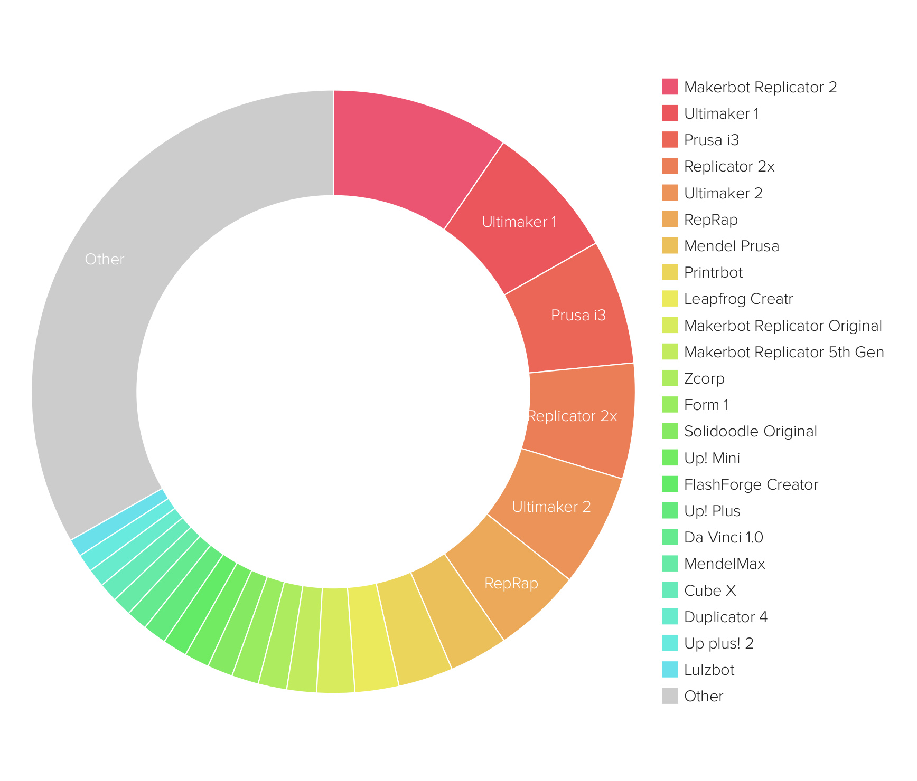

Glossary
Artifacts
Sometimes a digital model is of a poor quality and when “sliced” to produce the “gcode” it can produce unwanted features, layers, and other random “scribbles”. These errors are called “artifacts”.

ABS
Acrylnitrile-Butadien-Styrene – A particularly tough plastic commonly used in children's toys and Lego. It has a relatively high melting point compared to the more common PLA (see below) and because of its tendency to shrink as it cools can be quite challenging to print.

Arduino
An Open-Source microcontroller that is the heart of most 3D printers that are on the market at present. It is a programmable device capable of taking measurements with a range of sensors, controlling motors, and interfacing with a computer.

Engine
In the software context this is a dedicated piece of software or code that does the hard mathematical work calculating out something like the tool paths that the 3D printer extruder will need to follow to create the desired shape.

Extruder
The part of a 3D Printer that produces the line of molten plastic as the Printer builds the object. Typically the extruder is a fine nozzle with a heater and a device to force the filament into the heater and nozzle.

Extrusion Printer
These are the most common type of 3D Printer available for the home or small workshop. These printers use an extruder to lay down layers of molten plastic to produce the object.

Filament
All 3D Printers on the market for home and small workshop use a spool of plastic filament as the “raw material” from which the objects are built. The filament is passed into the extruder which melts it and exudes it as a fine stream of molten plastic into the object being made. The filament looks a bit like a spool of weed-eater nylon (and people have used weed-eater nylon as 3D Printer filament).

Fill
The fill is an expression for the amount of material used to fill the interior of an object. A 15% fill means that the interior of the object is 15% plastic and all the rest is air.

Fill Pattern
In order to achieve the desired density of fill the user can define a type of pattern to use; this might be “hexagonal” to give a honeycomb fill pattern, or “rectilinear” to give a cross hatch fill pattern.

gcode
When a model is “Sliced” the program works out what movements the 3D Printer extruder must do in order to create the shape for that layer. It writes these instructions into a gcode file. The gcode file could conceivably be read by a person because it is just a series of directions and measurements.

Handles
When working in graphics programs such as Blender, you may find a series of three coloured arrows appear whenever something is selected. These are called “Handles” and dragging on them will change the selected item(s) in some way in the direction of the handle you have dragged on.

Handworking Techniques
Working the old fashion way with hands and tools.

Laser cutting
Laser cutting and CNC milling are both complementary technologies to 3D printing where a laser or a router are guided around a shape to cut it out of a sheet of wood, plastic or metal.

Mesh
In the context of 3D modeling a “mesh” is the digital shape created within a 3D modeling computer package. The name derives from the fact that a mesh is a series of points joined by lines to describe the object's surface.

Microcontroller
An electronic device that can be programmed to do a variety of sophisticated tasks. They are not as complex as a computer but are able to interface with computers and with hardware such as motors, relays, etc.

Moderated
In the context of 3D Model websites this means that the models submitted are not checked by the website owners and operators.

OBJ
A common 3D Model format. Most 3D printer software can handle this format. It appears to be becoming the standard for multiple extruder printers because the OBJ format can carry colour information.

Open Source
Open Source means that the underlying code and intellectual property is available to be picked up by anyone wanting to develop it further, improve it. This means it cannot be patented and depending on the nature of the license it must only be distributed for free. Obviously there is a lot more to it than that and I would encourage you to look it up on the web as well as look at the Creative Commons License which is strongly associated with it.

PET
Polyethylene-Terephthalate. This is the same plastic in 1.5L soft drink bottles.

PLA
Polylactic Acid. A starch based bioplastic. This is the same plastic in supermarket bags and is the most common 3D Printing filament. It is a well behaved plastic with good 3D printing characteristics and moderately good strength.

Plugin
In the software context a plugin is a small bit of extra software you can add to some existing software to extend its functionality.

Reprap
The Reprap is the open source 3D Printer that is the original “parent” of most of the home and small workshop type printers available on the market at present. There are quite a few different variations. You can find all the instructions and files to build your own on the www.reprap.org website.

Slicer
A program for analysing 3D Digital models to develop the gcode that will guide the 3D printer as it creates the object.

Slicing
The term used to describe the process that a Slicer goes through to analyse a 3D digital model by considering it as a series of slices with a perimeter and the interior of the shape defined by the perimeter filled with a pattern that the program determines based on the amount of “fill” it has been told to achieve.

STL
This is the common format used for 3D Models and the 3D Printer software. This format does not carry any colour information.

Tool path
This is the line, and shapes that a printer extruder will follow in order to create the object. The gcode describes every step in the tool path.

Wireframe
In 3D modeling packages it is sometimes useful to make the faces on the model invisible. The view of the object then looks a little bit like it was made out of bits of wire describing the surface of the object – thus wireframe model. As it is just a way of viewing the model doing this does not affect the model itself and the view can be changed to show the faces again.



The document by Hamish Trolove is licensed under a
Creative Commons Attribution-NonCommercial-ShareAlike 4.0 International License.



Hamish Trolove

www.techmonkeybusiness.com

