3D Printing Introduction Workshop Plan
This workshop is 2 hours long and limited to 8 participants.
Each participant is provided with a laptop loaded with Blender, Sketchup, and Sculptris as well as Makerware.
There are three 3D printers available for printing the objects selected by the participants – Makerbot Replicator 2, XYZ Printing Da Vinci 1, and an Ultimaker.

This workshop plan is a slightly more efficient one than the other one available off this webpage – www.techmonkeybusiness.com/3d-printing-workshop-resources.html

Introductions
Welcome.
Who am I and what do I have to do with 3D Printing?
I will describe what I do and where 3D Printing fits into that.
Find out what the participants are looking to learn from this session.
After all there is no point going over stuff they already know or not interested in.
Explain some of the context for the lecture series and the workshops.
In the case of these workshops the local council (http://www.huttcity.govt.nz) is keen to raise the level of technical literacy within the city and this workshop series is a part of that.

Workshop Outline
What we're going to do.
- This is the first step along the way towards bringing your ideas for objects into reality using 3D printing.
- In the interests of efficiency we will jump straight into printing some items.
- The items are a sub-selection of Thingiverse models that are known to be good quality models and will also print within a reasonable time.
- Through the process of making the models ready for printing we will discuss the process steps and the typical interfaces you are likely to be faced with.
- While these items are printing we will discuss how your typical home 3D printer works, materials, maintenance, and general trends with what is available.
- We will get back onto the computers and discuss how to get hold of 3D Models.
- How to weed out the poor quality and unprintable models that you WILL encounter.
- We will spend a good deal of time looking at some of the software for making digital models for printing. After all it is here that the real effort occurs just as it is if you were writing something on the computer and sent it to the printer to produce a hard copy of your document.
- This will introduce you to Blender, Sketchup, and Sculptris which all have quite different ways of working. Try them all and see what works for you – this will be enough to get you started and some directions for how you can develop your skills further. I use Blender in my own work and so we will tend to use Blender to check the outputs from the other two.

The CD
On your CD you will find;
- A range of free and open source software such as the installers for Blender, Inkscape, Cura, Slic3r, ReplicatorG, and the Sketchup Plugin we will need.
- A number of tutorials for each of the digital design packages we are going to be using and a guide to those tutorials.
- A number of models from Thingiverse which were picked up in an effort to find some that could be printed in a reasonable time and might appeal to you.
- A guide to the models complete with the designers' descriptions and a link to the original Thingiverse files.
- A couple of general guides I have written too – these have things like where to find software, printers, filament etc with links etc. hopefully this will save you from having to frantically write notes.
- A tutorial about setting up Blender and some of the the basics we will be looking at in this workshop.

If you have problems with the CD, get in touch with me and I'll sort something out for you that will hopefully work better.. You can find my contact details through my website www.techmonkeybusiness.com.

Also on my website you will find a version of the “Guide to the Tutorials” document that links to the original documents on the web rather than the documents saved to the CD. The webpage for this is www.techmonkeybusiness.com/3d-printing-workshop-resources.html.

Hardware to Play With
We have three 3D Printers here;
The Makerbot Replicator 2 belonging to the Library
An XYZPrinting Da Vinci 1 3D printers kindly loaned by Comworth
and The Ultimaker from home.
These are all good examples of plastic extrusion printers that you would be likely to encounter in homes and small workshops. These are all derived from the Reprap.

Explain how they work, and features that make them good (ie good robust frames and in the case of the Makerbot, the maintenance menus.)

Preparing to Print
In the Documents directory on each computer is a folder called “Printable Models” which contains a selection of about 9 models that have been downloaded off Thingiverse (more on this later) and are known to be good quality models and will print in less than 30 minutes. The “Printable Models” selection is a subset of the selection on the CD provided.

Take some time to select a model that appeals, and we'll run that through the process of sending it to the 3D Printers. For the sake of this exercise we will use the Makerware software and export a file that can be put on an SD Card for transfer to the Makerbot. For the other printers we will redo the exercise on their software for whoever is keen to use those printers.

Slicing – Talk about profiles and settings. Explain what is happening when the model is “sliced”
Use Makerware to produce a g-code file that can be put on an SD Card.
Inspecting the gcode - Makerware – use the preview.
Guide participants through the process on the Da Vinci interface which is almost exactly like the Makerware, and through Slic3r – Printrun for the Ultimaker.

There are also online visualisation tools as well where g-code can be uploaded and this will create a visual representation of it. This is nothing Makerware and Cura can't do themselves.

How Home Plastic Extrusion 3D Printers Work
While the printers are running talk about the way they build up the object.
- Explain the different materials available and where to get them.
- Talk about build volumes and also explain that speed and big build volumes are not really all that important – it is less risky to build things smaller and in a modular fashion, and most of your time is spent designing rather than printing.
- Talk about rigidity in 3D Printers, filament size, heated beds etc.
- Talk about maintenance and the on-board menus for the Makerbot Replicator 2 and the XYZ Printing Da Vinci 1.
- Talk about modifications and their circulation on Thingiverse.
- Talk about cleanup tools that are useful to have; butter knife, painters tape, craft knife, rotary tools, and how you might paint the finished object.

Where can we get models from?
Download someone else's design
Scan an existing object
Design a brand new object or modify an existing model.

Model Repositories
Some examples of model repositories. You can create your own profile, and put your own design up. Big warning NOT ALL MODELS ON THESE SITES ARE PRINTABLE.
Thingiverse – (Makerbot)
Show them the website and how it works.
Show them a model page and the information tabs, download tab, license, and derivatives.
Youmagine – Ultimaker
Pinshape – This is a moderated site and so the designs are vetted for quality. They also offer a printing service.

Have a browse, feel inspired.

Assessing a Model
OK. We've got ourselves something that interests us. How do we know if it will print?
Clues to look for:
- Overhangs (Maybe it can be printed upside down)
- Very slender or thin sections.
- Are there signs that the designer has printed it themselves? photos?
- Check the comments or the model – others may have tried to print it and failed.
Demonstrate this with a browse through the latest additions to Thingiverse. Explain that sometimes a model can be made printable by rotating the object or by using support.

If it passes those initial tests there may still be problems.
- non – manifold: Show examples from the downloaded models. Blender will be used to highlight the problem. Refer to Meshlab as a free tool for checking and sometimes fixing errors.
- Glitched: Scale or rotation will fix it. Example is the Hexagonal Tile model on the CD. Scale and rotation can often be fixed within the “Slicer”.

Some can be fixed easily,others cannot.

The “Slicers” are getting better at handling these errors but it pays to check the g-code they produce just in case. If it's full of “scribbles” it's a dud.

Scanning an Existing Object
Explain that some desktop 3D Scanners are starting to appear on the market. I have not used one so I'm not sure of the quality of the output.

Photogrammetry. Talk about this briefly and explain about the models you get back. It is important to have a messy background to the photos you upload. Mention the existence of http://www.123dapp.com/catch.

Designing
This is where the rubber hits the road. Most of your time will be spent here rather than feeding stuff to the printer. After all a 3Dprinter is just a device for turning a digital model into something real in the same way that a printer is just a tool for turning a digital document into a real document with words and pictures on paper.

Say you need to modify a 3D model file you have downloaded because it is faulty or you need to customise it, or you feel the need to create something the world has never seen before, you will need to make a digital model of your item. I will show you three free tools for doing that. There are others, but in my experience these are a couple of the most versatile and in the case of Blender, the most powerful.

This is a “Taste test” of three design programs with quite different ways of working. You may find that one works better for you that the others. That is good and that's what we're trying to do. We will illustrate the ways of working with Blender and Sketchup by modifying an existing model in Blender and then I shall demonstrate building a simple and very ugly bracket in Sketchup (Feel free to follow along with this as I go). Sculptris....well we'll just play with that.

Blender – Open Source modeling and animation package. Very powerful. In modeling for 3DPrinting we will only be scratching the tiniest part of the surface of what it can do. It has a learning curve that is like a cliff-face but we will hopefully be learning enough today to get you up that cliff-face and onto the plateau beyond. Blender has a heap of tools now for 3D Modelling. The meshes it produces are of high quality.
Sketchup – Very intuitive and an amazingly well designed tool. You will be able to produce most things you can imagine on this. The downside is that the meshes can be a bit nasty.
Sculptris – this is a 3D Sculpting tool and very intuitive. It is an enticer for Z-brush. The mesh quality is excellent, but you may need to use support or modify the output in Blender to make it printable.

Blender
Within the Documents folder there is a directory called “LikeIt”. This was a small model I built for the Hutt City Libraries to use for demonstrating 3D Printing. It took 10 minutes to design using Inkscape and Blender, and about 20 minutes to print.
In the folder is a .blend file. Open this with Blender.
Show how to;
- discover the interface,
- move the views using the mouse and the numeric keypad,
- go into edit mode,
- selecting vertices, edges, and faces,
- move, scale, and rotate parts of the model to alter its overall shape,
- and how to extrude.
If the participants are doing well with this then show them how to punch holes and fill faces.

Sketchup
I shall demonstrate building this bracket using exact dimensions. Observe the use of the nodes that snap to corners, and halfway distances.
- Discuss the various tools in the tool bar.
- Show how a line can divide the region.
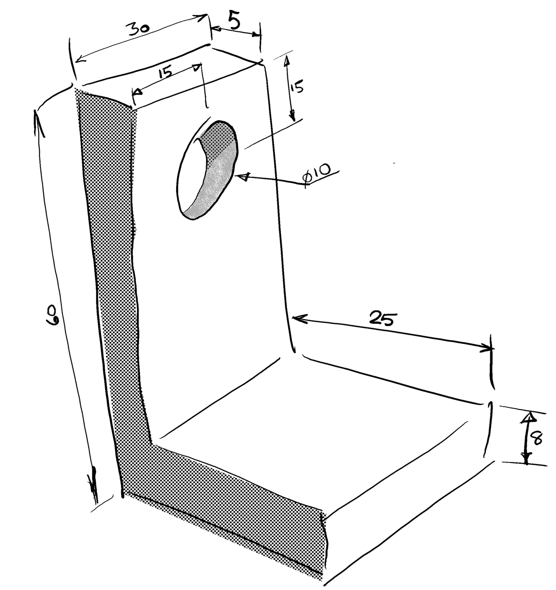
- Demonstrate measuring tools and guides to locate the circle.
- Push through hole – key in depth or just push through until measurement indicates that it is deep enough.
- Exporting the STL using the plugin.

The Bracket

Discuss ways of achieving this shape (extrusion or cutting bits out.)
Discuss how we should orientate this out to maximise printability and strength - note that there is often a trade-off here as this example illustrates quite well.
Talk about the effects that different printing orientations will have on the hole.

Sculptris
This is best with a tablet and stylus where you can use the pressure sensitivity.
Discuss various tools
Play
Export OBJ
Demo using blender to flatten the bottom or orientating it to make it printable.

Closeout
Let the printing continue if still more to do.
Encourage questions.
If still time encourage the participants to open an STL in Sketchup or Blender and inspect it or modify it.

Talk about OpenSCAD, Inkscape, and Meshlab.

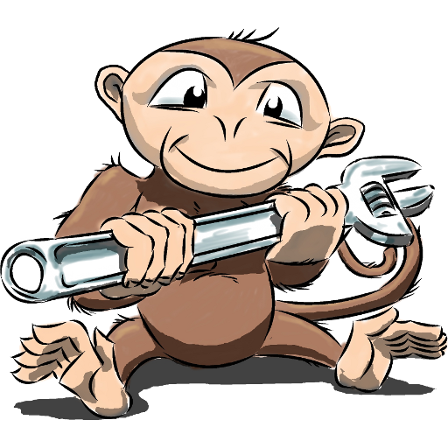

www.techmonkeybusiness.com

