3D Printing Introduction Workshop Plan
This workshop is 2 hours long and limited to 8 participants.
Each participant is provided with a laptop loaded with Blender, Sketchup, and Sculptris as well as Makerware.
There are four 3D printers available for printing the objects selected by the participants.

Introductions
Welcome.
Who am I and what do I have to do with 3D Printing?
I will describe what I do and where 3D Printing fits into that.
Find out who attended the recent 3D Printing lecture series.
After all there is no point going over stuff they already know.
Explain some of the context for the lecture series and the workshops.
In the case of these workshops the local council (http://www.huttcity.govt.nz) is keen to raise the level of technical literacy within the city and this workshop series is a part of that.

Workshop Outline
What we're going to do.
- This is the first step along the way towards bringing your ideas for objects into reality using 3D printing.
- We will be talking about the typical type of 3D printer you are likely to encounter in the home or small workshop.
- We will show you where you can get 3D models from if you are looking for ones designed by others.
- How to weed out the poor quality and unprintable models that you WILL encounter.
- We will go through the process of getting a model and printing it out. We will be using a subset of models that have originated from Thingiverse in the hope of finding models that will print within the time available so that you can take them away with you. These models are on the CD we're giving you.
- We will spend a good deal of time looking at some of the software for making digital models for printing. After all it is here that the real effort occurs just as it is if you were writing something on the computer and sent it to the printer to produce a hard copy of your document.
- This will introduce you to Blender, Sketchup, and Sculptris which all have quite different ways of working. Try them all and see what works for you – this will be enough to get you started and some directions for how you can develop your skills further. I use Blender in my own work and so we will tend to use Blender to check the outputs from the other two.

The CD
On your CD you will find;
- A range of free and open source software such as the installers for Blender, Inkscape, Cura, Slic3r, ReplicatorG, and the Sketchup Plugin we will need.
- A number of tutorials for each of the digital design packages we are going to be using and a guide to those tutorials.
- A number of models from Thingiverse which were picked up in an effort to find some that could be printed in a reasonable time and might appeal to you.
- A guide to the models complete with the designers' descriptions and a link to the original Thingiverse files.
- A couple of general guides I have written too – these have things like where to find software, printers, filament etc with links etc. hopefully this will save you from having to frantically write notes.
- A tutorial about setting up Blender and the basics we will be looking at in this workshop.

If you have problems with the CD, get in touch with me and I'll sort something out for you that will hopefully work better.. You can find my contact details through my website www.techmonkeybusiness.com.

Hardware to Play With
We have four 3D Printers here;
The Makerbot Replicator 2 belonging to the Library
Two XYZ Da Vinci 3D printers kindly loaned by Comworth
and The Ultimaker from home.
These are all good examples of plastic extrusion printers that you would be likely to encounter in homes and small workshops. These are all derived from the Reprap.

Explain how they work, and features that make them good (ie good robust frames and in the case of the Makerbot, the maintenance menus.)

What can be built on these?
Have some examples to show
- Quadcopters
- Repraps
- Repair of goods (anyone bring any?)
- Small production run manufacture
- Patterns for casting.
- Board game pieces.

Where can we get models from?
Some examples of model repositories. You can create your own profile, and put your own design up. Big warning NOT ALL MODELS ON THESE SITES ARE PRINTABLE.
Thingiverse – (Makerbot)
Show them the website and how it works.
Show them a model page and the information tabs, download tab, license, and derivatives.
Youmagine – Ultimaker
Pinshape – This is a moderated site and so the designs are vetted for quality. They also offer a printing service.

Have a browse, feel inspired, and if you find something you like the look of shout out and we'll see if we can printed within the time available.
Otherwise we'll need to use the subset I have pulled together and find something there. I have tried to cover all tastes -within reason. I'll advise the designers that we have used their model in a workshop if we print one out.

Assessing a Model
OK. We've got ourselves something that interests us. How do we know if it will print?
Clues to look for:
- Overhangs (Maybe it can be printed upside down)
- Very slender or thin sections.
- Are there signs that the designer has printed it themselves? photos?
- Check the comments or the model – others may have tried to print it and failed.

If it passes those initial tests there may still be problems.
- non – manifold: Show examples from the downloaded models. Blender will be used to highlight the problem. Refer to Meshlab as a free tool for checking and sometimes fixing errors.
- Glitched: Scale or rotation will fix it. Example is the Hexagonal Tile example. Scale and rotation can often be fixed within the “Slicer”.

Some can be fixed easily,others cannot.

The “Slicers” are getting better at handling these errors but it pays to check the gcode they produce just in case. If it's full of “scribbles” it's a dud.

This naturally leads us onto Printing the model.

Preparing to Print
We have our model in an STL or OBJ format (Even the DAE format that Sketchup produces natively is able to be accepted by some “Slicers”)

Slicing – Talk about profiles and settings
Demonstrate – Makerware, Slice3r,and Cura (These last two are on my Linux Workstation for the Ultimaker)
Inspecting the gcode - Makerware – use the preview.
Printrun – use the viewer.

There are also online visualisation tools as well where gcode can be uploaded and this will create a visual representation of it. This is nothing Makerware and Cura can't do themselves.

Printing
Hit “print” with Printrun and the Ultimaker. Use one of the model selected by the workshop participants.
Load something onto the SD Card for the Makerbot and set them going. Use one of the model selected by the workshop participants.

Your turn.
Take your selected model and run it through the Makerware software and do a preview. Load it to the SD card when you are ready and we'll get it into the machine.
If you want to use the Ultimaker jump on Slic3r on the Linux workstation and generate the gcode.
For the Da Vinci's load the models onto their and set them going.

Designing
This is where the rubber hits the road. Most of your time will be spent here rather than feeding stuff to the printer. After all a 3Dprinter is just a device for turning a digital model into something real in the same way that a printer is just a tool for turning a digital document into a real document with words and pictures on paper.

Say you need to modify a 3D model file you have downloaded because it is faulty or you need to customise it, or you feel the need to create something the world has never seen before, you will need to make a digital model of your item. I will show you three free tools for doing that. There are others, but in my experience these are a couple of the most versatile and in the case of Blender, the most powerful.

This is a “Taste test” of three design programs with quite different ways of working. You may find that one works better for you that the others. That is good and that's what we're trying to do. We will illustrate the ways of working with Blender and Sketchup by building the same object in each. Sculptris....well we'll just play with that.

Blender – Open Source modeling and animation package. Very powerful. In modeling for 3DPrinting we will only be scratching the tiniest part of the surface of what it can do. It has a learning curve that is like a cliff-face but we will be learning enough today to get you up that cliff-face and onto the plateau beyond. Blender has a heap of tools now for 3D Modelling. The meshes it produces are of high quality.
Sketchup – Very intuitive and an amazingly well designed tool. You will be able to produce most things you can imagine on this. The downside is that the meshes can be a bit nasty.
Sculptris – this is a 3D Sculpting tool and very intuitive. It is an enticer for Z-brush. The mesh quality is excellent, but you may need to use support or modify the output in Blender to make it printable.

The Bracket
In Blender and Sketchup we will have a crack at building a bracket – a very very basic and uninteresting bracket with no style or flair whatsoever. This will illustrate some fundamental techniques; extrusion, and putting holes in things.

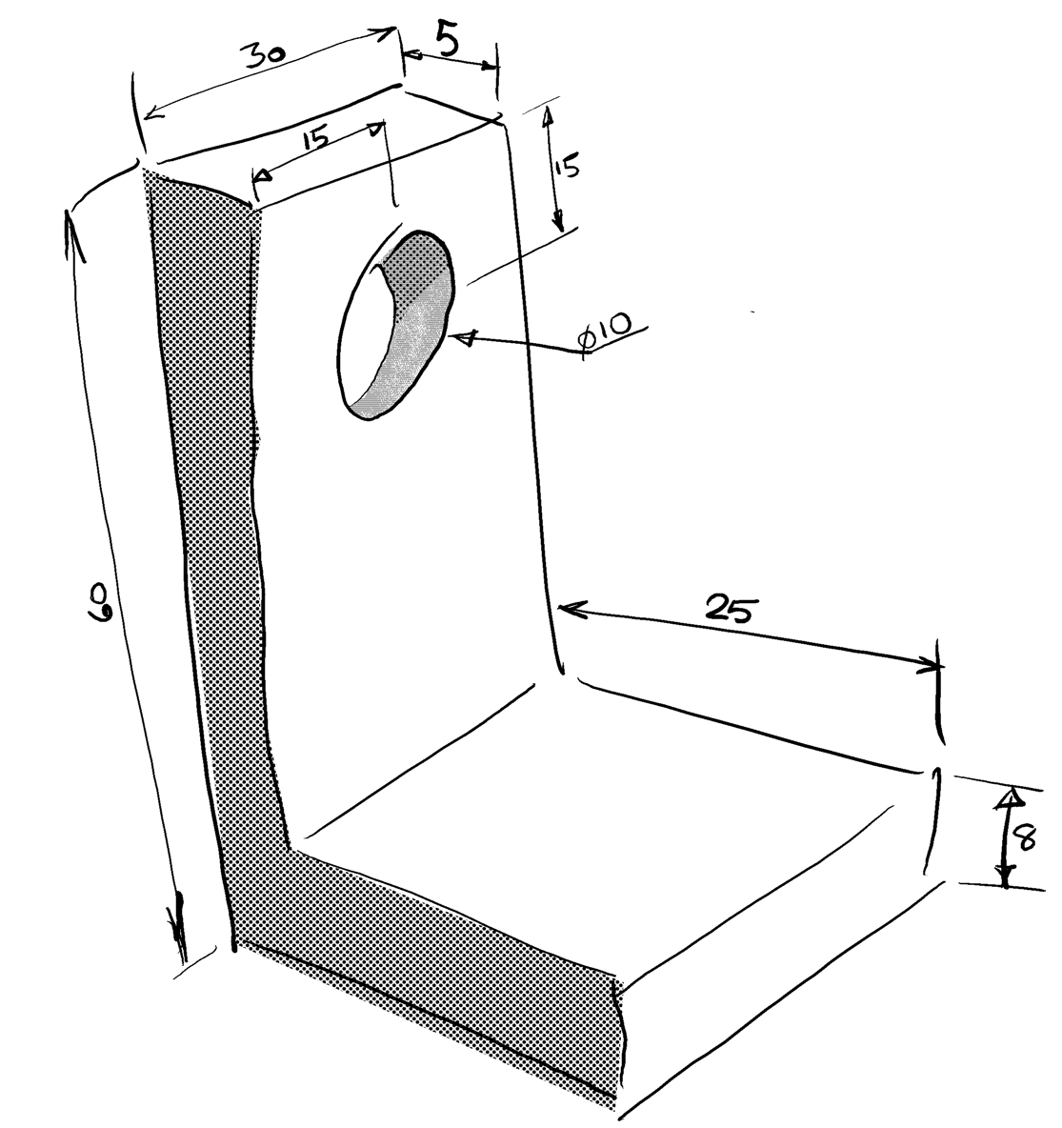

Discuss ways of achieving this shape (extrusion or cutting bits out.)
Discuss how we should orientate this out to maximise printability and strength - note that there is often a tradeoff here as this example illustrates quite well.
Talk about the effects that different printing orientations will have on the hole.

Blender
Discuss set up of defaults – refer to CD
The default cube dimensions. Dragging out or key in scale.
Subdivide
Extruding
Cylinder size
Rotating and moving
Using z = 0 scale to flatten a surface.
Deleting and filing faces
Check mesh
Produce STL.

Sketchup
Discuss where to find the panels to use - especially the measuring panel.
Discuss the various tools
Draw the shape – show the guide points.
Remove the extra line
Push up
Using measuring tools and guides to locate the circle.
Push through hole – key in depth or just push through until measurement indicates that it is deep enough.
Export STL using the plugin.

Sculptris
This is best with a tablet and stylus where you can use the pressure sensitivity.
Discuss various tools
Play
Export OBJ
Demo using blender to flatten the bottom or orientating it to make it printable.

Closeout
Let the printing continue if still more to do.
Encourage questions.
If still time encourage the participants to open an STL in Sketchup or Blender and inspect it or modify it.

Talk about OpenSCAD, Inkscape, and Meshlab.



The document by Hamish Trolove is licensed under a
Creative Commons Attribution-NonCommercial-ShareAlike 4.0 International License.



Hamish Trolove
www.techmonkeybusiness.com

